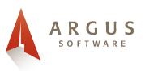
User Profile: Kevin Hamlin
Kevin is the information systems director for RE/Max International.
RE/MAX International is an international real estate company. It was founded in Denver, Colorado and is still owned privately
RE/MAX International oversees a network of more than 120,000 agents in more than 65 countries with more than 6,000 offices.
Kevin’s Responsibilities
Eliminating redundancies between branches of the corporation.
Consolidating asset management tools.
Ensuring operating efficiency for all software used by RE/Max
Maximizing management efficiency.

